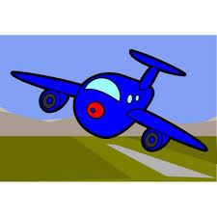
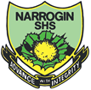
BECOME A HOLIDAY PLANNER

In pairs use the following pages to plan a holiday for two adults.
Your holiday can last as long or as short as you like but plan wisely.

You must:
- Choose one location (anywhere in the world)
- Choose some activities (they must be appropriate e.g. no scuba diving in the centre of Paris!)
- Choose a board option (what food will you have?)
- Choose as many items from the packing list as you wish
- Stick to the weight that you pay for on the plane

YOU HAVE A BUDGET OF $8,000
Don’t exceed (go over) your budget!

Section D) what will you take? (10 Marks)
ITEM | DETAILS | Weight (kg) | PRICE | TICK
Basic unisex clothing package | Contains seven t-shirts and seven pairs of shorts | 5.0 | $25.00
Clothing package | Contains a variety of good quality tops, shorts and skirts from Factory Top-Shop. Forever New and Cotton on and (seven days’ worth of clothes) | 6.5 | $107.00
Designer Clothing Package | Contains a variety of very stylish and top quality clothing from brands including D&G, Bvlgari, Hugo Boss, Armani, Juicy Couture and more! (Includes seven days’ worth of clothes) | 9.5 | $540.00
Primark Sunglasses | Look good but break easily and don’t provide good protection from the sun | 0.1 | $7.00
Gucci Sunglasses | Very chic! Must be bought with cleaning kit | 0.1 | $470.00
Gucci Sunglasses Cleaner | A must have! | 0.1 | $15.00
Hairdryer | Some hotels might provide this | 2.0 | $40.00
Straighteners |  | 1.3 | $120.00
Ladies’ Hair Care Kit | Hairspray, mousse, bobbles and hair grips | 0.9 | $30.00
Men’s Hair Care Kit | Contains hair gel | 0.1 | $5.00
Basic Thongs (Target) | Ideal for men and women | 0.1 | $3.50
Deluxe Thongs by SuperDry | Men’s and women’s available | 0.2 | $18.00
Make-up Set |  | 0.6 | $29.00
Basic Toiletry Set | Contains shampoo, soap, 2 x toothbrushes and toothpaste, hairbrush | 1.4 | $5.00
Deluxe Toiletry Set | Shampoo, conditioner, toothpaste, 2 x toothbrushes, mouthwash, his and hers shower gel, hairbrush and comb | 2.3 | $14.00
Passport | A must have! | 0.1 for two | $98.00
Beach Towels | Some hotels may provide these! | 0.4 | $11.00
Ipad | Perfect for the beach, plane and hotel! | 0.1 | $109.00
Sun Cream | Sun-cream and after sun – perfect for those hot sunny days! (1 week) | 0.3 | $19.00
Magazines and books | Ideal for the plane and the beach – assortment to suit all tastes | 0.1 | $9.00

(2 marks per item appropriate to your destination.)

Which holiday (B) Location
Location | Flight Duration (hours) | Costa Nada Hotel (*)  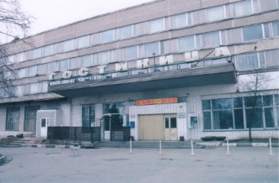 | Westin Peace Lodge (**)  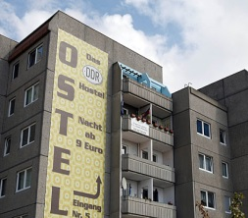 | Averados Hotel (***)  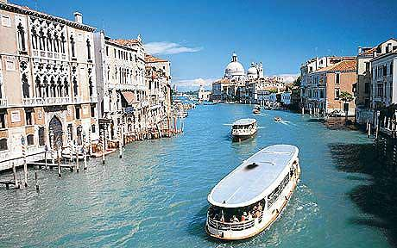 | Ritz Hotel (****)  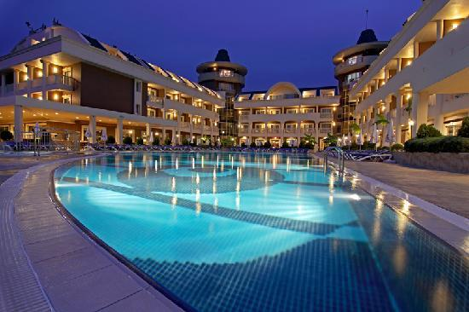 | Costa Packet Hotel (*****)  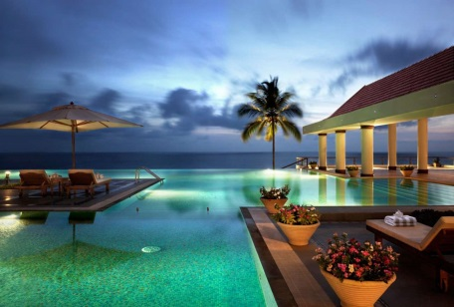
Turkey | 16 | $1.50 | $2.05 | $3.50 | $4.90 | $7.10
Florida | 23 | $2.50 | $3.10 | $5.60 | $8.40 | $13.20
Paris | 20 | $2.70 | $4.50 | $6.30 | $9.20 | $18.00
Greece | 16 | $0.75 | $1.25 | $2.40 | $3.80 | $4.20
Bali | 4 | $1.80 | $2.90 | $3.80 | $5.60 | $6.90
New Zealand | 7 | $1.10 | $1.90 | $3.20 | $4.65 | $5.00
Mauritius | 8 | $3.00 | $6.00 | $8.00 | $13.50 | $21.40
Singapore | 5 | $1.00 | $1.20 | $1.80 | $5.80 | $8.20
Canberra | 4 | $2.10 | $6.20 | $11.50 | $19.80 | $27.50
Prices are per night for two people sharing and include breakfast. (5 marks)
To upgrade to all inclusive, add 25% to the price. (5 marks)
Section A) Which holiday (Flights)
All flight prices quoted are from Sydney and include both directions. To fly from Perth, add 5% to the price. (10 marks)

Duration | Economy – cheap and cheerful! | Premium Economy – more leg room and free drinks and snacks! | Business Class – even more leg room, three course meal, free drinks, snacks and newspaper | First Class – as per business class but also includes a lie down bed, blankets and private cabin
4 hours | $201.00 | $325.00 | $370.00 | $560.00
5 hours | $251.00 | $375.00 | $420.00 | $610.00
7 hours | $301.00 | $425.00 | $470.00 | $660.00
8hours | $351.00 | $475.00 | $520.00 | $710.00
16 hours | $401.00 | $525.00 | $570.00 | $760.00
20hours | $601.00 | $725.00 | $770.00 | $960.00
23 hours | $801.00 | $925.00 | $970.00 | $1160.00

Prices do not include fuel and airport tax. An additional 15 % must be added to the price quoted to find the total price. (5 marks)
Why did you choose this holiday? (5 marks)

Luggage: luggage is charged at $7.00 per kilogram. (5 marks)

Travelling to the airport: Taxi fare = 15c per Kilometres
Perth = 200 Kilometres (5 marks)

(Section C) What will you do? (20 Marks)
Activity | Available in these countries: | Details | Price per adult
White Water Rafting | Turkey, Greece, Spain, Outer Hebrides | Enjoy a fun filled morning white water rafting through the valleys before a BBQ lunch in the forest. Lunch included | $15.00
Jeep Safari | Turkey, Greece, Outer Hebrides, Canary Islands, Spain | Venture into the woods and see all that nature has to offer, including a variety of species native to the country. Full day, lunch included | $175.00
Open-Top Sightseeing Tour | Paris, London, Spain, Greece, Florida | Board an open top bus and see everything your city has to offer, including famous landmarks! Two day pass and complimentary boat ride included | $68.00
Theme Park Tickets | Florida, Paris, London, Canary Islands | Visit a theme park of your choice for a full day! Transport included | $59.00
Boat and Snorkelling Trip | Turkey, Greece, Canary Islands, Spain, Mauritius, Outer Hebrides | All aboard! A full day trip, making three stops for snorkelling. All equipment, lunch and drinks included | $34.00
Romantic Dinner for Two | All locations | You will have your own table on the beach and be served by your own private butler! Enjoy fine cuisine and drinks as you watch the sun set | $109.00 for two people
Pirates Dinner Show | All locations | Arrive to a swashbuckling evening of fun and all the food you can eat! | $44.00
Spa Experience | Mauritius | Only available at 4 and 5 star hotels. Enjoy 3 x 60 minute spa treatments from the spa menu | $229 for two people
(5 marks per activity)

(Section B) Money, Money, Money Spending Money (30 marks)
How much spending money will you take? (5)Think about eating, drinking and activities, as well as keeping money for emergencies (5). Use the graphs below to convert to the correct currency (20)

Australian Dollars

Australian Dollar

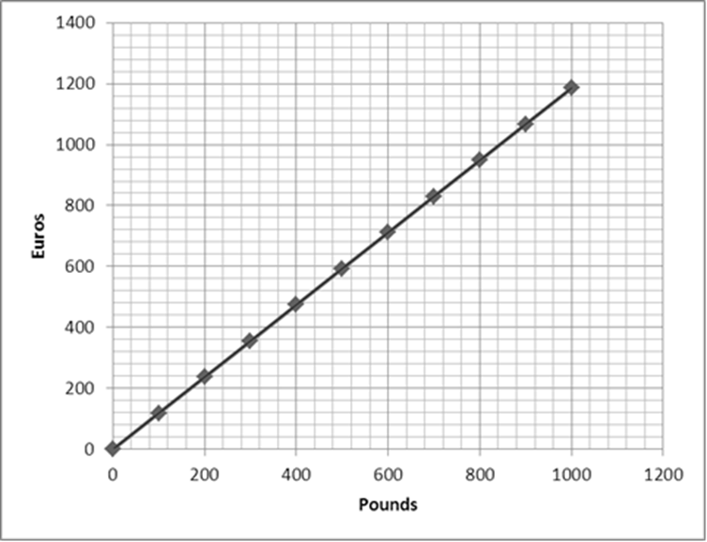
Australian Dollar
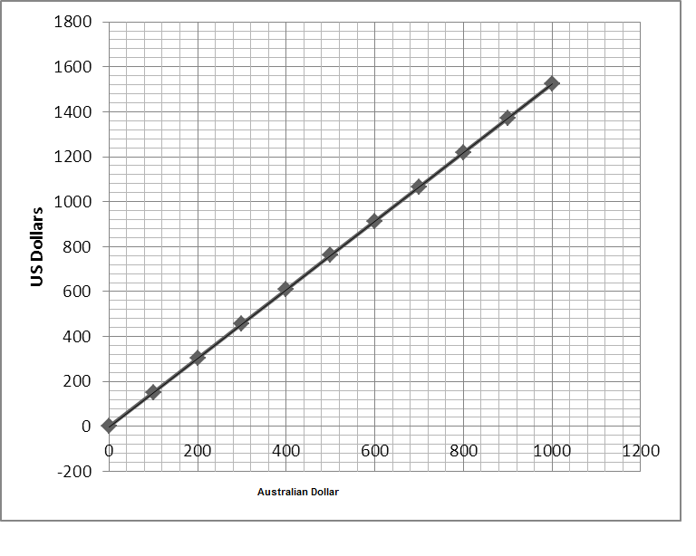

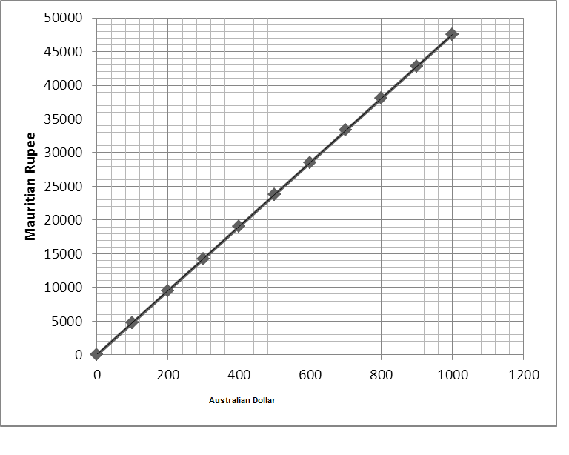
Indonesian Rupiah


Singapore Dollar

